EMSINA National Symbology Standards

Symbology Styled Layer Descriptors

**I. Introduction**

In the context of emergency management in the twenty-first century, the focus has become interagency response, including countless agencies organizations. This requires the implementation of a single national map symbology standard for use between all agencies involved. Styled Layer Descriptors (henceforth ‘SLD’) is a method which defines rule sets and visualization of symbology for point, line, and polygon features across datasets, provided attribution and naming convention requirements are met.

This document serves as an overview of SLD basics, storage, attribution, and naming convention requirements, and accessibility features of the new EMSINA SLD’s.

**II. Data**

SLD’s work by way of XML coding for rule sets and visualization requirements for datasets which may or may not be linked to graphic files which might be in several formats. The graphic formats used for this SLD set is Scaled Vector Graphic (henceforth SVG). The initial data you will receive will be in a template format. There will be one zip file containing three folders and two documents detailing the symbology and information for each feature, as well as a symbology table. One is of all *.SVG files requires for SLD implementation. Once unzipped, you will see a hierarchal structure of groups, then a separate folder each for points, lines, and polygons (see below).

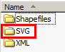🡪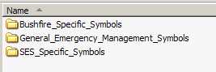🡪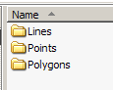

The second folder within the zipped file contains three *.XML files, one each for points, lines, and polygons (see below).

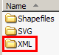🡪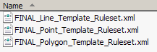

Again, each *.XML file contains all commands that control the visualization and functionality of each symbol.

The third folder contains template shapefiles, one each for points, lines, and polygons (see below).

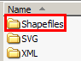🡪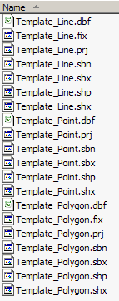

These are for you to view the symbology associated with the EMSINA groups.

**III. Software and File Storage**

First, ensure you have downloaded and installed GeoServer version 2.1.3. This software will allow you to visualize the template data. The storage of your files is paramount to the successful execution of your SLD’s. Once GeoServer is successfully installed on your system, it will automatically create a directory structure on your hard drive. This is the directory structure GeoServer accesses during operation. There are two specific directories we will address here. The first is the directory for your shapefile storage. In C:\Program Files\Geoserver 2.1.3 you will see several directory folders. Open ‘data_dir’ (see below).

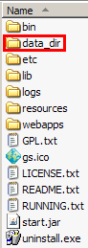

Within ‘data_dir’ there will be still more directories. Now open ‘data’ (see below).

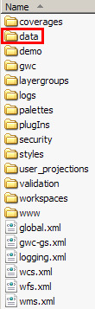

Now in here there will be several directories. Open ‘shapefiles’ (see below).

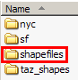

You will now copy your shapefiles into this directory.

Now move up two levels back to the ‘data_dir’ directory. Now open the ‘styles’ directory (see below).

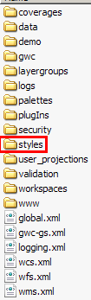

In here you will find already several files. Disregard these. You will now copy all of your *.SVG files into this directory. You must copy the individual *.SVG files from each folder and subfolder into this directory. You cannot just copy the group folders over.

**IV. Attribution**

The attribution for your shapefiles must comply with EMSINA SLD standards. The following attribution standards apply for the Points, Lines, and Polygons shapefiles, respectively (see below):

Points



Your Points shapefile must have the following fields:

FID(default)

Shape(default)

Id(default)

Symbol – This identifies the feature by its name.

Feature – This identifies the technical feature name to which the XML Style points to apply rule sets to specific feature types for visualization.

Theme – This is related to the group under which this feature falls.

AIIMS – This describes the nature of this feature relative to AIIMS.

Lines



All fields are the same as Points, except for the addition of one field:

Orient – This is the orientation describer for line features which need to point in different directions, depending on certain situations. For line features which should point to the right, a ‘0’ value is applied to this field, and for line features which should point to the left, a ‘1’ value is applied. This rule is then read by the XML Style and applied accordingly.

Polygons



All fields are the same as Points.

**V. GeoServer Operation**

Now start GeoServer 2.3.1 (see below).

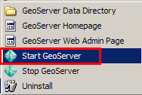

An MS command prompt window will open. It will start the GeoServer engine on your local machine. This will take approximately one minute. You will see the screen ready once the following message is displayed (see below):

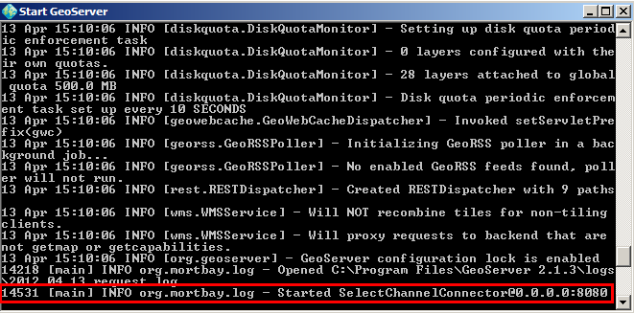

Now you will access the GeoServer Web Admin Page (see below).

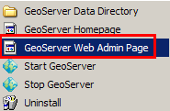

This will open automatically in your web browser. Login with the following defaults, no caps:

Username: admin

Password: geoserver

Now you will be within your local GeoServer admin page. You will see a screen with several links. We will focus on the ‘Data’ group on the upper-left (see below).

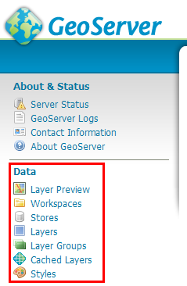

First, create your Workspace. This can be anything.

Workspaces>Add new workspace, name it.

Now you will need to create 3 new Stores. These are the template shapefiles for points, lines, and polygons which you unzipped and stored previously.

Stores>Add new Store, procedure detailed below.

Select ‘Shapefile’ (see below).

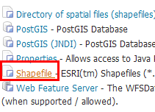

Select your Workspace you just created, and this Data Source Name will be ‘Template_Shapefile_Point’. You will now Browse to your shapefile under ‘Shapefile location’ (see below).

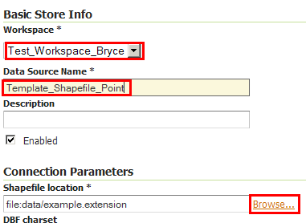🡪

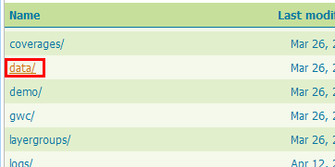🡪

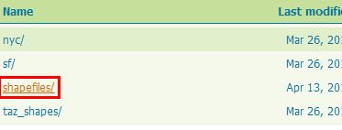🡪

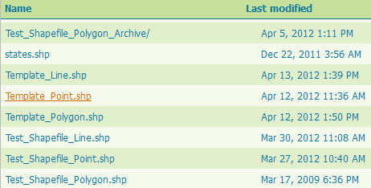

Now repeat this step for the Line and Polygon shapefiles.

You will now create a new Style for each layer.

Styles>Add a new style, see detailed instructions below.

You will now create a new Style for the Points layer. Name this ‘Template_Point’. You will copy ALL TEXT from your point *.XML file you unzipped into the command box here and save it. These are all commands you need (see below).

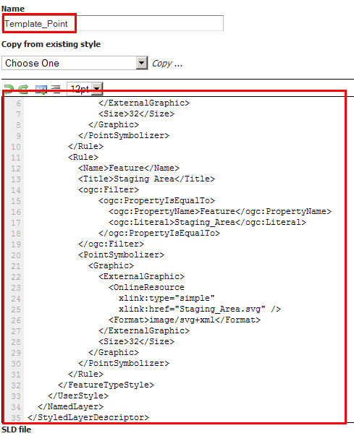

Now select ‘Validate’ at the bottom. If there are no validations then select ‘Submit’. Repeat this process for Lines and Polygons.

Now you will create your new layer. Select: Layers>Add a new resource, follow instructions below.

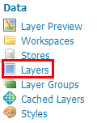🡪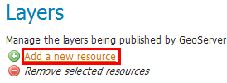

Select your Workspace:Store from ‘Add layer from’ dropdown menu. Select ‘Publish’ under ‘action’.

Now you will be prompted with a new screen; set the following settings:

Under the ‘Data’ tab, you must set your Coordinate Reference System (CRS) (see below). Search for ‘4283’ and select it to set the CRS to GDA94 for your layer.

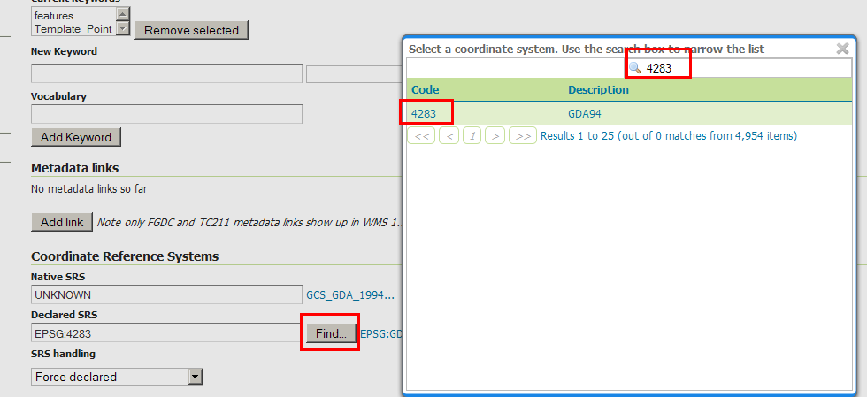

Select ‘Compute from data’ and ‘Compute from native bounds’ under ‘Bounding Boxes’ (see below).

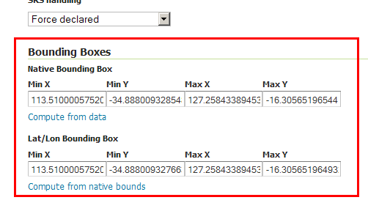

Select your ‘Publishing’ tab. Under ‘WMS Settings, set your ‘Default Style’ to ‘Template_Point’, which chooses to represent this shapefile using the XML code you pasted into your ‘Template_Point’ Syle previously (see below).

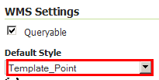

Now select ‘Save’ at the bottom.

You should now be able to view your layer with its appropriate symbology.

Select: Layer Preview>OpenLayers for ‘Template_Point’ (see below).

